Admin@DESKTOP-61APHF9 MINGW64 ~

$ cd d:/jd2_hw

Admin@DESKTOP-61APHF9 MINGW64 /d/jd2_hw (master)

$ git branch task12

Admin@DESKTOP-61APHF9 MINGW64 /d/jd2_hw (master)

$ git checkout task12

Switched to branch 'task12'

Your branch is up to date with 'origin/task12'.

Admin@DESKTOP-61APHF9 MINGW64 /d/jd2_hw (task12)

$ git status

On branch task12

Your branch is up to date with 'origin/task12'.

nothing to commit, working tree clean

Admin@DESKTOP-61APHF9 MINGW64 /d/jd2_hw (task12)

$ git push

Logon failed, use ctrl+c to cancel basic credential prompt.

Everything up-to-date

Admin@DESKTOP-61APHF9 MINGW64 /d/jd2_hw (task12)

$ git checkout master

Switched to branch 'master'

Your branch is up to date with 'origin/master'.

Admin@DESKTOP-61APHF9 MINGW64 /d/jd2_hw (task12)

$ git checkout master

Already on 'master'

D hw2/task12/src/main/resources/developers.xml

Your branch is ahead of 'origin/master' by 1 commit.

(use "git push" to publish your local commits)

Admin@DESKTOP-61APHF9 MINGW64 /d/jd2_hw (master)

$ git merge task12

Updating 3c9c292..cf02659

Fast-forward

hw2/task12/src/main/java/com/doctorsweb/database/Const.java | 2 +-

.../src/main/java/com/doctorsweb/database/DoctorsRepositoryImpl.java | 4 ++--

2 files changed, 3 insertions(+), 3 deletions(-)

Admin@DESKTOP-61APHF9 MINGW64 /d/jd2_hw (master)

$ git push

Logon failed, use ctrl+c to cancel basic credential prompt.

Everything up-to-date

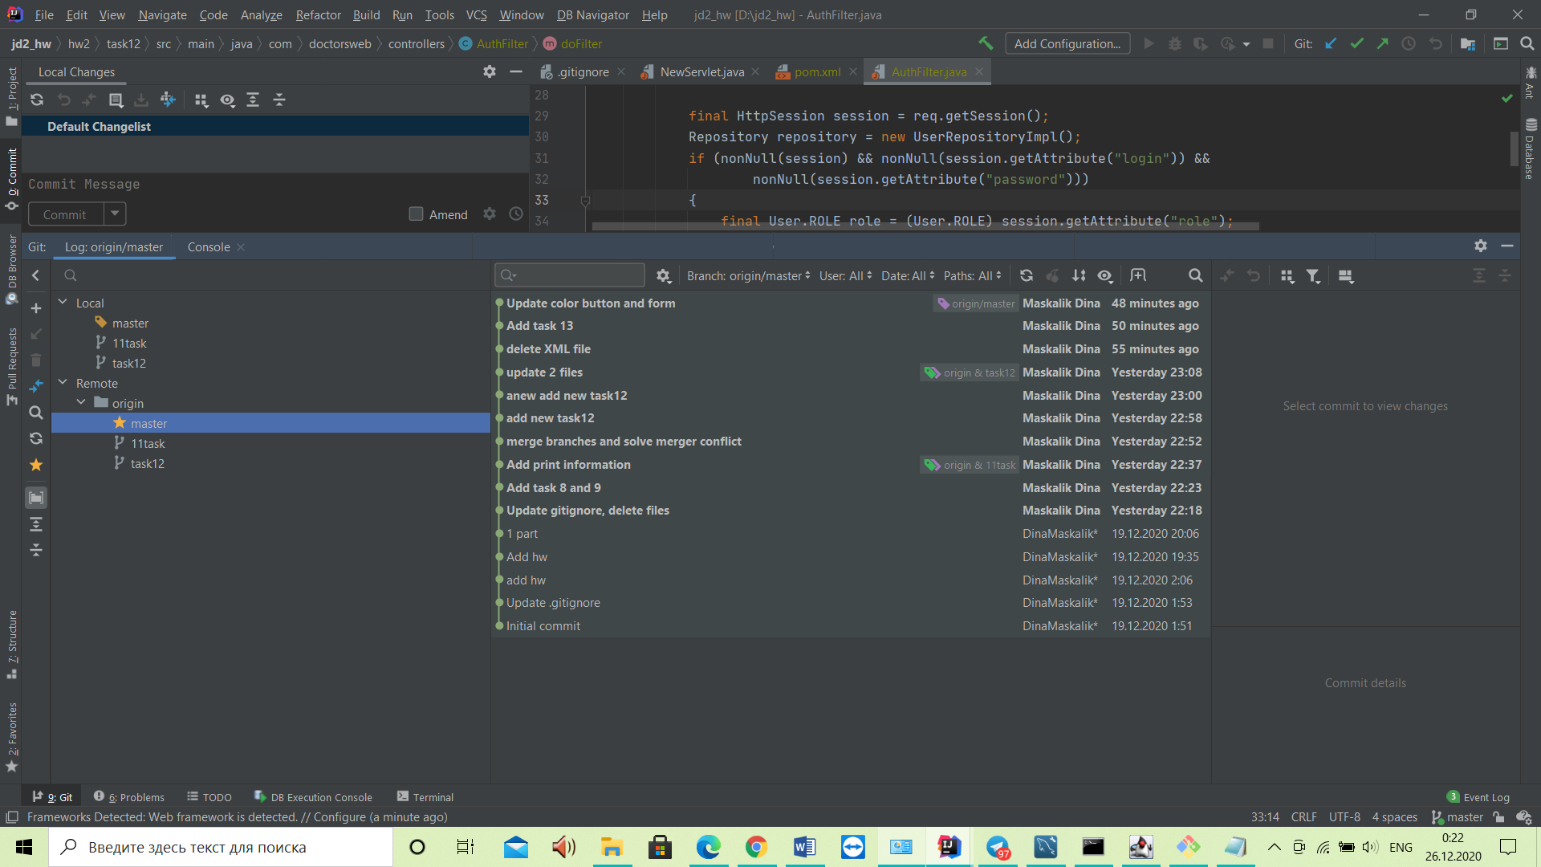

Комиты master

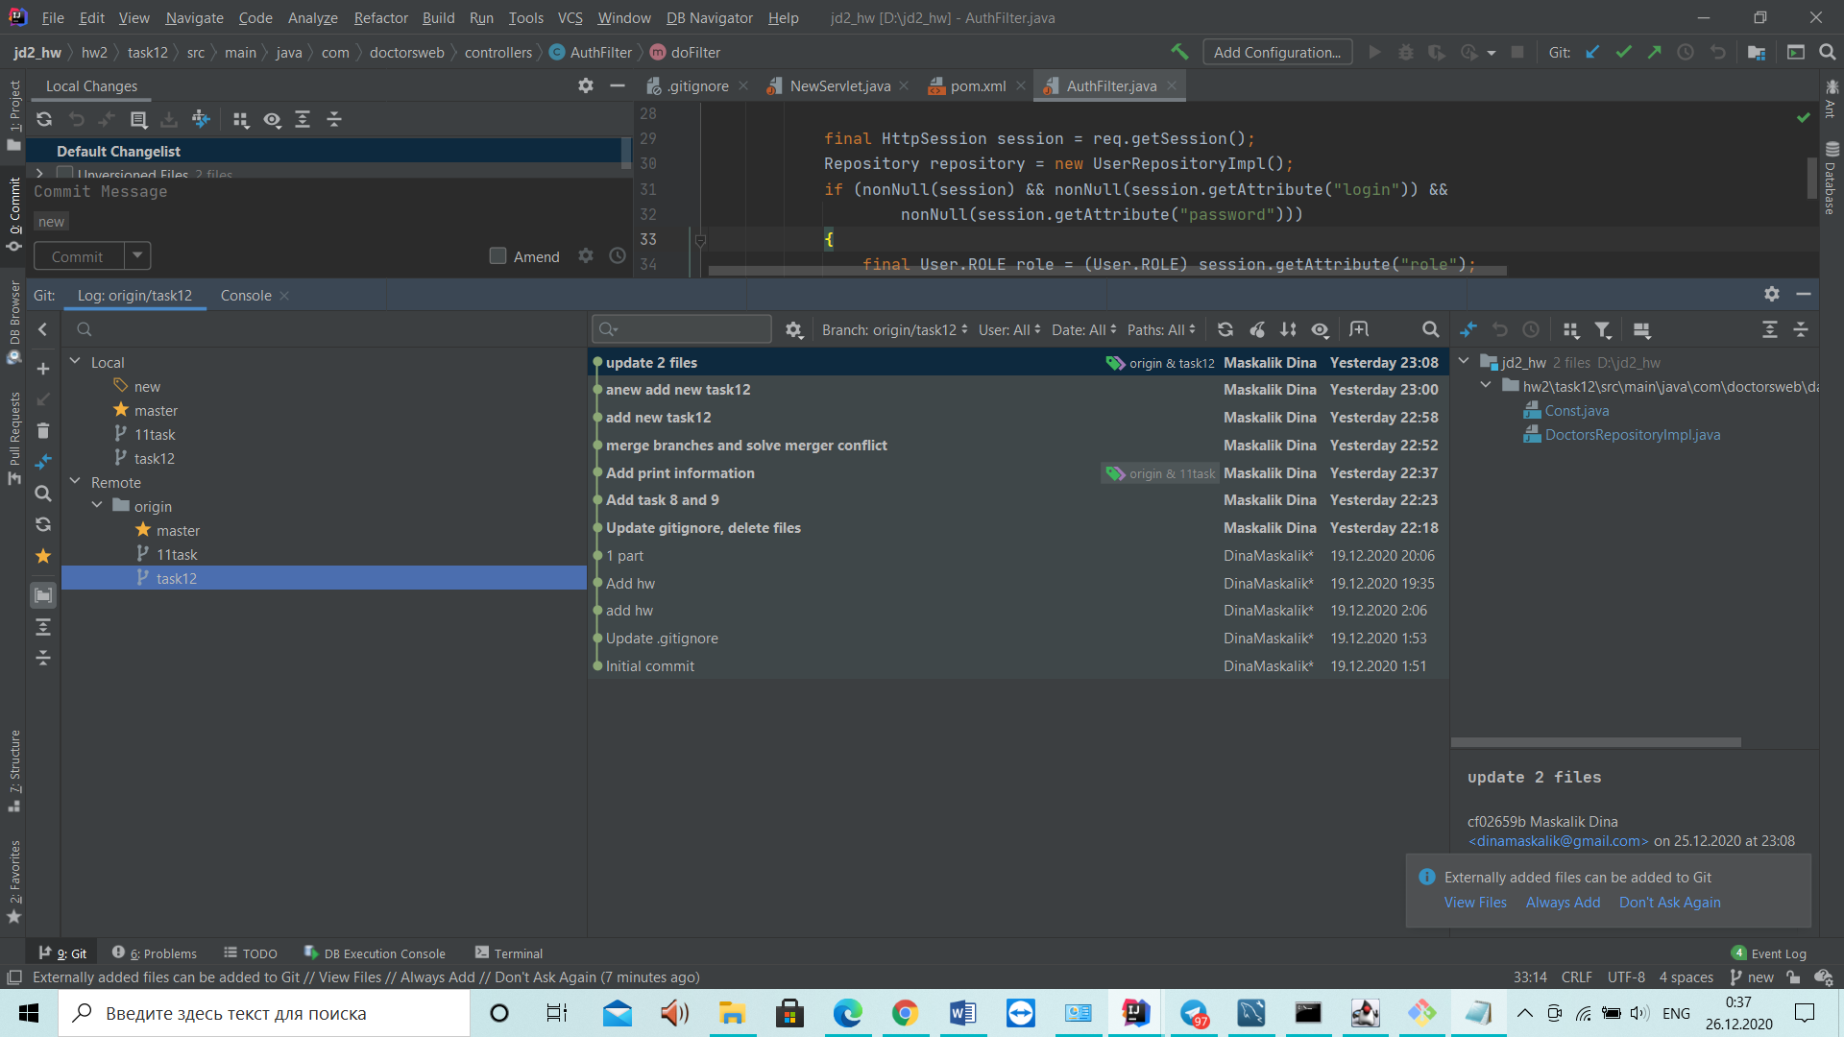

Комиты task12